Career Portfolio

Anthony Meunier

DeVry University

CARD 405

CONTENTS

Statement of Authenticity 3

Personal Mission Statement 4

Elevator Speech 5

Education 6

I. DeVry Plan of Study 6

II. DeVry Course Descriptions 9

III. DeVry Academic History 15

Resumé 17

Professional Development and Training 19

References 20

Reference List 22

Awards and Accomplishments 23

Volunteer History 24

Professional Affiliations 25

Career Pathing 26

Work Samples 27

# Statement of Authenticity

I, Anthony Meunier, hereby declare that I am the author of all the materials contained within this career portfolio, and that the materials contained in this portfolio are my original works and that it is an honest representation of my skills. This portfolio of work may not be copied or shared without my permission.

# Personal Mission Statement

To live a life of integrity and act with ethical principles in all that I do.

To strive to be a leader and be an impressionable, positive example for all others.

To constantly reestablish the best version of myself in order to maintain a well-balanced, forward-moving lifestyle.

# Elevator Speech

I am a recent graduate of DeVry University’s Computer Information Systems bachelor’s degree program with a concentration in Health Information Systems. In my education I’ve really enjoyed learning and developing techniques related to process analysis, object-oriented principles, and procedural programming as they allow me to emphasize some of the principles I pride myself on in order to be a skillful and efficient problem-solver. Critiquing and analyzing these types of systems and concepts is important to me because it serves as the basis in helping to build something bigger, better, and new; being on the cutting edge of development is something I consider very challenging and fun.

# Education

## DeVry Plan of Study

Student: Meunier, Anthony Level: Undergraduate

ID: D40200422 Campus: CA Palmdale

Class: Senior Degree: Bachelor of Science

Cumulative GPA: 4.00 Program: Computer Info Systems

Residence: Domestic Concentration: Health Information Systems

*Estimated Degree Progress*

Requirements: 98%

**Computer Info Systems BCIS_US**

**Communication Skills**

Composition

Composition ENGL 112 Composition

Advanced Composition ENGL 135 Advanced Composition

Tech Writing, Journalism ENGL 230 Professional Communication

or Professional Writing

**HUMANITIES REQUIREMENT**

Humanities, Literature, ETHC 445 Principles of Ethics

Film or Fine Arts

History, Ethics, Logic, HIST 405 United States History

Comp Religions or Phil

Technology, Society and LAS 432 Tech, Society, and Culture

Culture

**SOCIAL SCIENCES**

Social Science Requirement PSYC 110 Psychology

Social Science Requirement ECON 315 Microeconomics

Social Science Requirement SOCS 185 Culture and Society

**PERSONAL & PROFESSIONAL DEVELOPMENT**

CAREER DEVELOPMENT

*Career Development CARD 405 Career Development

Critical Thinking & COLL 148 Critical Thinking & Problem-

Problem-Solving Solving

**MATHEMATICS AND NATURAL SCIENCE**

Algebra for College MATH 114 Algebra for College Students

Students

Statistics for Decision MATH 221 Statistics for Decision-

Making Making

Science Course GEOL 101 Physical Geology

**BUSINESS**

Essentials of Accounting ACCT 301 Essentials of Accounting

Introduction to Business BUSN 115 Intro to Business &

& Technology Technology

Project Management MGMT 404 Project Management

**SYSTEMS CONCEPTS**

Logic & Design CIS 115 Logic and Design

Architecture & Operating CIS 206 Archit and Operating Sys

Systems with Lab w/ Lab

Connectivity with Lab CIS 246 Connectivity with Lab

Computer Applications COMP 100 Computer Apps for Busn

For Business with Lab w/ Lab

Principles of Information SEC 280 Principles Info Sys Security

Systems Security

**PROGRAMMING**

Programming with Lab CIS 170B Programming with Lab

Object-Oriented CIS 247A Obj-Oriented Programming

Programming with Lab w/ Lab

Business Application CIS 355A Business App Programming

Programming with Lab w/ Lab

**WEB DEVELOPMENT**

Web Interface Design CIS 363A Web Interface Design

with Lab with Lab

*Web Application CIS 407A Web App Development

Development with Lab w/ Lab

**SYSTEMS DEVELOPMENT**

Structured Analysis CIS 321 Structured Analysis &

& Design Design

Introduction to Database CIS 336 Introduction to Database

with Lab w/ Lab

Object-Oriented Analysis CIS 339 Obj-Oriented Analysis-

& Design Design

**SENIOR PROJECT**

SENIOR PROJECT

*Computer Information CIS 470 CIS Senior Project

Syst Senior Project

**Health Information Systems Track**

Advanced Database with Lab DBM 405A Advanced Database with Lab

*Health Information Systems I HIS 410 Health Info Systems I

*Health Information Systems II HIS 420 Health Info Systems II

Organizational Process Analysis SAI 460 Org Process Analysis

Data Privacy & Security SEC 360 Data Privacy and Security

* In Progress

## DeVry Course Descriptions

**ENGL 112 – Composition**

This course cultivates writing skills through analysis of essays, articles and other written works that are used as models for writing practice and development. Writing assignments emphasize process approaches, development, organization, revision and audience awareness. Students use word-processing and online tools to develop written work.

**ENGL 135 – Advanced Composition**

This course builds on the conventions and techniques of composition through critical reading requirements and longer, more sophisticated reports, including a documented library research paper. Assignments require revising and editing for an intended audience. Students are also taught search strategies for accessing a variety of print and electronic resources.

**ENGL 230 – Professional Communication**

This course enhances students' writing and presentation skills for academic applications and professional communication in the workplace. Students analyze the needs of divergent audiences, and craft messages using technology tools and media appropriate for distance and group communication. An emphasis on collaborative work further prepares students for the contemporary work environment.

**ETHC 445 – Principles of Ethics**

This course provides knowledge of ethics students need to make moral decisions in both their professional and personal lives. Combining moral theories and applied ethics topics, coursework helps students explore traditional and contemporary ethics dilemmas, as well as reflect on and evaluate their moral beliefs. Balancing respect for diversity and claims of universality, the course puts ethics principles in the social and cultural context of the world today.

**HIST 405 – United States History**

This course examines American history from the formation of the 13 original colonies to the present. Coursework addresses the struggle to define American citizenship and government, development of the nation and a national economy, and racial exclusion in American society. Also examined are the country's transformation to a world power, Reconstruction, resurgence, recession and reform, principles of justice and the American experience.

**LAS 432 – Technology, Society, and Culture**

In this capstone course, the relationship between society and technology is investigated through reading, reflection, research and reports. The course identifies conditions that have promoted technological development and assesses the social, political, environmental, cultural and economic effects of current technology. Issues of control and ethical considerations in the use of technology are primary. Discussion and oral and written reports draw together students' prior learning in specialty and general education courses.

**PSYC 110 – Psychology**

This course provides a foundation for understanding, predicting and directing behavior. Organized within a framework encompassing foundations, general topics and applications, the course provides an understanding of how psychological principles and concepts relate to professional and personal life. Topics include learning, attitude formation, personality, social influence, dynamics of communication, conflict resolution, motivation, leadership, and group roles and processes.

**ECON 315 – Microeconomics**

Building on principles introduced in ECON-312, this course focuses on microeconomic topics dealing with market forces and the behavior of individual consumers, firms and industries. Key areas emphasized are supply and demand, competition, market structure, utility theory, production costs, labor markets and the role of government in the economy.

**SOCS 185 – Culture and Society**

This course explores the role of culture in social organizations. Social institutions, and the issues of race and gender within social structures, are analyzed in the context of multicultural societies and increasing global interaction. Basic sociological principles and research findings are used to support analysis of cultural and social issues.

**CARD 405 – Career Development**

Career planning strategies and resources are explored to prepare students for a successful job search and to maximize potential for advancement and long-term professional growth. Students perform self-assessment and goal-setting activities, and apply research and evaluation skills to execute job search and career advancement strategies. Each student assembles a professional portfolio highlighting achievements, goals and concrete plans.

**COLL 148 – Critical Thinking and Problem-Solving**

This course focuses on identifying and articulating skills needed for academic and professional success. Coursework provides instruction and practice in critical thinking and problem-solving through analysis of critical reading and reasoning, as well as through examination of problem-solving methodologies. Students learn to work in teams, to identify and resolve problems, and to use research effectively to gather and evaluate relevant and useful information.

**MATH 114 – Algebra for College Students**

This course focuses on systems of linear equations; radical and rational expressions; and functions where linear, quadratic, exponential and logarithmic functions are emphasized using application problems and modeling. The minimum requirement to pass this course is 80 percent, and grades of C and D are not assigned. Eligibility to enroll in the course is based on placement results, or successful completion of MATH-092 or MATH-102.

**MATH 221 – Statistics for Decision-Making**

This course provides tools used for statistical analysis and decision-making in business. The course includes both descriptive statistics and inferential concepts used to draw conclusions about a population. Research techniques such as sampling and experiment design are included for both single and multiple sample groups.

**GEOL 101 – Physical Geology**

Introduction to the Earth’s geologic features and processes responsible for their formation. Students will learn about the internal and external processes involved with the formation of the Earth. Topics include the formation of minerals and rocks, tectonic processes, volcanoes, earthquakes, faults and folding, the development of continents and ocean basins, mineral and energy resources, and surface processes and features including weathering, streams, groundwater, glaciers and shorelines.

**ACCT 301 – Essentials of Accounting**

This course is intended for students in technology-intensive programs, where understanding basic principles of finance and managerial accounting is essential to successful contribution to organizational achievement. Students are introduced to the accounting system, financial statements, and essential elements of cost and managerial accounting within the context of management decision-making. Capital investment analysis and other budgeting methods are studied in relation to goal attainment and organizational success. The effect of activities in the functional areas of business on organizations' financial viability is emphasized.

**BUSN 115 – Introduction to Business and Technology**

This course introduces business and the environments in which businesses operate. Students examine the roles of major functional areas of business and interrelationships among them. Organizational theories and techniques are examined, and economic, cultural, political and technological factors affecting business organizations are evaluated.

**MGMT 404 – Project Management**

This course enhances students' ability to function in a project leadership role. While exploring the project life cycle, they gain experience in budget and timeline management. Project management software is used to design project schedules using methods such as bar charts, program evaluation review technique (PERT) and critical path method (CPM) to produce project plans to apply to the solution of case studies.

**CIS 115 – Logic and Design**

This course introduces basics of programming logic, as well as algorithm design and development, including constants, variables, expressions, arrays, files and control structures for sequential, iterative and decision processing. Students learn to design and document program specifications using tools such as flowcharts, structure charts and pseudocode. Program specification validation through desk-checking and walk-throughs is also covered.

**CIS 206 – Architecture and Operating Systems with Lab**

This course introduces operating system concepts by examining various operating systems such as Windows, UNIX and Linux. Students also study typical desktop system hardware, architecture and configuration.

**CIS 246 – Connectivity with Lab**

This course covers fundamentals of data communication and computer networking, including the Open Systems Interconnection (OSI) model. Network architecture and configurations such as local area networks (LANs) and wide area networks (WANs) are addressed.

**COMP 100 – Computer Applications for Business with Lab**

This course introduces basic concepts and principles underlying personal productivity tools widely used in business such as word processors, spreadsheets, email and web browsers. Students also learn basic computer terminology and concepts. Hands-on exercises provide experience in using PCs and current personal productivity tools.

**SEC 280 – Principles of Information Systems Security**

This course provides a broad overview of information systems security in organizations. Topics include security concepts and mechanisms; mandatory and discretionary controls; basic cryptography and its applications; intrusion detection and prevention; information systems assurance; and anonymity and privacy. Various types of controls used in information systems, as well as security issues surrounding the computer and computer-generated data, are also addressed.

**CIS 170B – Programming with Lab**

This course introduces basics of coding programs from program specifications, including use of an integrated development environment (IDE), language syntax, as well as debugger tools and techniques. Students also learn to develop programs that manipulate simple data structures such as arrays, as well as different types of files. C#.Net is the primary programming language used.

**CIS 247A – Object-Oriented Programming with Lab**

This course introduces object-oriented programming concepts including objects, classes, encapsulation, polymorphism and inheritance. Using an object-oriented programming language, students design, code, test and document business-oriented programs. C#.Net is the primary programming language used.

**CIS 355A – Business Applications Programming with Lab**

Building on analysis, programming and database skills developed in previous courses, this course introduces fundamental principles and concepts of developing programs that support typical business processing activities and needs such as transaction processing and report generation. Students develop business-oriented programs that deal with error handling, data validation and file handling. Java is the primary programming language used.

**CIS 363A – Web Interface Design with Lab**

This course introduces web design and basic programming techniques for developing effective and useful websites. Coursework emphasizes website structure and navigational models, practical and legal usability considerations, and performance factors related to using various types of media and tools such as hypertext markup language (HTML), cascading style sheets (CSS), dynamic HTML (DHTML) and scripting. Dreamweaver and Flash are the primary software tools used.

**CIS 407A – Web Application Development with Lab**

This course builds on analysis, interface design and programming skills learned in previous courses and introduces basics of design, coding and scripting, as well as database connectivity for web-based applications. A programming language such as Visual Basic.Net, C++.Net or C#.Net is used to implement web-based applications. ASP.Net is the primary software tool used.

**CIS 321 – Structured Analysis and Design**

This course introduces the systems analysis and design process using information systems methodologies and techniques to analyze business activities and solve problems. Students learn to identify, define and document business problems and then develop information system models to solve them.

**CIS 336 – Introduction to Database with Lab**

This course introduces concepts and methods fundamental to database development and use including data analysis and modeling, as well as structured query language (SQL). Students also explore basic functions and features of a database management system (DBMS), with emphasis on the relational model.

**CIS 339 – Object-Oriented Analysis and Design**

Building on the foundation established in CIS321, students explore techniques, tools and methods used in the object-oriented approach to developing applications. Students learn how to model and design system requirements using tools such as Unified Modeling Language (UML), use cases and scenarios, class diagrams and sequence diagrams.

**CIS 470 – Computer Information Systems Senior Project**

Working in teams, students apply knowledge and mastered skills, including problem-solving techniques and project-management methods, to an applications-oriented project. The project provides real-world experience by integrating systems analysis, programming, testing, debugging, documentation and user interfacing techniques.

**DBM 405A – Advanced Database with Lab**

This course introduces database implications of efficient and effective transaction processing, including error handling, data validation, security, stored procedures and triggers, record locking, commit and rollback. Data mining and warehousing are also explored. Oracle is the primary relational database management system (RDBMS) used.

**HIS 410 – Health Information Systems I**

This course introduces healthcare medical and business processes from a software design perspective. Topics include history of - and current topics related to - the healthcare delivery process; healthcare functions supported by hospital IT departments; and interaction between healthcare and business data domains, and medical and allied health professionals. The electronic health record is introduced.

**HIS 420 – Health Information Systems II**

In this course, current technologies, regulations and standards, including picture archiving and communication systems (PACS); the Health Insurance Portability and Accountability Act (HIPAA); 21 CFR Part 11; FDA General Principles of Software Validation; and Health Level Seven (HL7), are explored, as are their effects on software development. Information technologies used to store data, maintain data quality, ensure safety and enforce security are studied. Case studies on electronic health record system introductions are reviewed, and current electronic health record system designs are studied.

**SAI 460 – Organizational Process Analysis**

This course addresses analytical techniques used to model process flow. Process rules and process maturity are explored in the context of characterizing workflow effectiveness and identifying opportunities for process improvement. Also covered are systematic approaches for comparing existing processes to process change solutions, documenting requirements for resource proposals and change management competencies critical for successful implementation.

**SEC 360 – Data Privacy and Security**

This course focuses on legal, ethical and security issues involving data and information assets organizations must address to ensure operational continuity as well as compliance with standards, policies and laws. Students examine various levels of threats to an organization's data and develop standards, policies, procedures and plans to combat them. Security technology specific to safeguarding data and information assets is also covered.

## DeVry Academic History

*March 2016*

CIS 470 CIS Senior Project In Progress 3.00

*January 2016*

HIS 410 Health Information Systems I In Progress 3.00

HIS 420 Health Information Systems II In Progress 3.00

*November 2015*

CARD 405 Career Development In Progress 2.00

CIS 407A Web App Development w/ Lab In Progress 4.00

*September 2015*

SEC 360 Data Privacy and Security A 4.00

SAI 460 Org Process Analysis A 4.00

*July 2015*

CIS 355A Business App Programming w/ Lab A 4.00

*May 2015*

LAS 432 Tech, Society, and Culture A 3.00

DBM 405A Advanced Database w/ Lab A 4.00

*March 2015*

CIS 339 Obj-Oriented Analysis A 3.00

CIS 336 Introduction to Database w/ Lab A 4.00

*January 2015*

MGMT 404 Project Management A 4.00

CIS 321 Structured Analysis & Design A 3.00

*November 2014*

SEC 280 Principles Info Sys Security A 3.00

CIS 363A Web Interface Design w/ Lab A 4.00

*September 2014*

CIS 247A Obj-Oriented Prgrming w/ Lab A 4.00

CIS 246 Connectivity w/ Lab A 4.00

*July 2014*

CIS 170B Programming w/ Lab A 4.00

*May 2014*

CIS 115 Logic and Design A 3.00

ENGL 227 Professional Writing A 4.00

*March 2014*

ENGL 230 Professional Communication A 3.00

ACCT 301 Essentials of Accounting A 4.00

*January 2014*

MATH 221 Statistics for Decision-Making A 4.00

CIS 206 Archit and Operating Sys w/ Lab A 4.00

*November 2013*

MATH 114 Algebra for College Students A 4.00

ENGL 135 Advanced Composition A 4.00

# Resumé

**Anthony Meunier**

43157 Carol Drive • Lancaster, California 93535 • (818) 312-5838 • ameunier1@my.devry.edu

**Summary** —Targeting entry-level information technology positions

* Quickly learn and master new technologies; demonstrates success in both team and self-directed projects.
* Proficient in a wide range of computing systems, languages, tools and testing methodologies.
* Personable and positive; applies interpersonal aptitude to effectively communicate with coworkers, clients, and vendors.
* Flexible, hardworking and can adapt easily to changes in both schedule and work environment; welcomes challenges and applies each and every unique experience to personal and professional growth.
* Energetic and dedicated; reputation for consistently going beyond what is required.

**Education & Credentials**

**DeVry University Expected May 2016**

Candidate for a Bachelor of Science in Computer Information Systems

* 4.00 GPA
* Concentration in Health Information Systems
* Dean’s List Recipient, Every Semester in Attendance

**Antelope Valley College June 2011**

Associate in Arts in Liberal Arts and Sciences: Social/Behavioral Sciences

* 3.56 GPA, Graduated Magna Cum Laude
* President’s List Recipient, Spring 2009
* President’s List Recipient, Spring 2011

**Technology Summary**

* Systems: Unix, Linux, Windows OS, Mac OS
* Databases: Oracle, Relational Databases
* Languages: Visual Basic, C#, Java, SQL, HTML, CSS, ASP.NET
* Software: Visual Studio, Microsoft Visio, Microsoft Office, Microsoft Project

**Work History**

**Staples Office Supply 05/2014 – Present**

Sales Associate Palmdale, CA

* Process and complete sales through use of a cash register.
* Highlight and help locate best available products and their features based upon customer’s needs.
* Prepare and maintain clean working stations and environment.
* Organize and zone store inventory on a daily basis to present and uphold a brand image.

**Best Buy 10/2012 – 02/2013**

Geek Squad Installer Palmdale, CA

* Aided in the installation and setup of home theater equipment by properly determining and using any necessary tools while understanding and following housing-code in order to efficiently and safely complete all jobs.
* Interacted with clients in an in-home setting and served as a facilitator of strong customer-company relations by personally contacting and following up with customers on behalf of the company; handled most processes of communication with client outside of initial store experience.
* Used an Order Management System to ensure all facets and components necessary to process and expedite setup and completion of job-related functions were in order.

**Thermal Comfort Systems 06/2007 – 08/2011**

Clerical / Data Entry Northridge, CA

* Performed data entry via QuickBooks.
* Organized and filed important account documents and invoices.
* Assisted in everyday office tasks including: answering and redirecting phone calls, scheduling appointments, and communicating with clients via fax and email.

References available upon request.

# Professional Development and Training

*CompTIA A+

*CompTIA Network+

*CompTIA Security+

*MTA: Microsoft Technology Associate – Networking Fundamentals

*MTA: Microsoft Technology Associate – Security Fundamentals

*MTA: Microsoft Technology Associate – Windows Operating System Fundamentals

*Oracle 11g Certified Associate (SQL)

* In Progress

# References

Reference Letter for Anthony Meunier

11/19/15

Prepared by Dr. Ken Melichar

LAS 432 Instructor

Anthony Meunier was a student in my May 2015 LAS 432 Capstone Course. The capstone course is designed to have students work together in teams as they complete course research project. There were three members in Anthony Meunier’s group. The title of the project was “Additive Manufacturing and the 3-D Opportunity.” Anthony and his team completed a course project that demonstrated Anthony’s ability to work in a team, producing a well research, well written and professional paper. Using an online presentation site they presented their paper to the rest of the class. Their presentation was professionally done. They kept to their allotted time for their presentation.

In addition to these two major projects, students have to participate in graded threaded discussions during the 8 week course. Students were assessed based on the length and quality of their discussions. Anthony’s discussions demonstrated his mastery of the assigned reading material related to technology and society. In short Anthony’s participation in the course was thoughtful, critical, and informative earning him 980 points out of a possible 1000. I highly recommend him.

November 21, 2015

To Whom It May Concern:

This is a letter of recommendation for Mr. Anthony Meunier

I have known Anthony for one term as he was a student in my CIS course at DeVry. His skills and abilities in how he commands Computer Information Systems show great potential for this new undertaking of his. Anthony had mentioned to me his future intentions of employment. One of the questions you may ponder is whether or not this person is qualified.

Please rest assured that any decision that you make in favor of Anthony would definitely be worth it. Anthony is extremely committed to achieving his goals. He is bright, intelligent and always has a pleasant attitude. He has outstanding leadership and human relations’ skills. His peers look up to him. He has set a *precedent* for this institution that is an example for other students to follow. I strongly recommend that you consider Anthony because I can’t think of anyone this academic school year more deserving of this opportunity.

If there are any other questions in which I could assist you in your decision making process, please feel free to contact me.

Sincerely,

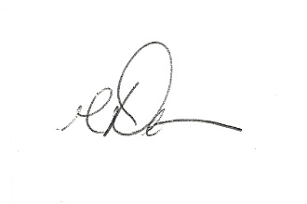

**David A. Thomas, Ed.D.**

Visiting Faculty

College of Engineering and Information Sciences

**DeVry University**

3005 Highland Parkway

Downers Grove, IL   60515-5799

dthomas8@devry.edu

909 643 3472



# Reference List

**Philip Bidnick, Sales Manager**

Staples Office Supply

39258 10th St W

Palmdale, CA 93551

*661-265-7630*

**Pamela Brown, Office Manager**

Thermal Comfort Systems

8038 Andasol Avenue

Northridge, CA 91325

*818-705-4060*

**Natalie Busse, Registered Nurse**

Antelope Valley Hospital

1600 W Avenue J

Lancaster, CA 93534

*661-618-5491*

**Jose Romero, Geek SquadField Supervisor**

Best Buy

39330 10th St W

Palmdale, CA 93551

*661-547-9429*

# Awards and Accomplishments

**DeVry University**, Spring2016

*Summa Cum Laude, 4.00 GPA*

Dean’s List Award Recipient

Spring 2015

Fall 2014

Summer 2014

Fall 2013

**Antelope Valley College**, June 2011

*Magna Cum Laude, 3.56 GPA*

President’s List Award Recipient

Spring 2011

Spring 2009

# Volunteer History

American Red Cross – Blood Drive

Elysian Valley Community Garden – Urban Garden Senior Planting

L.A. Works – Spark the Youth, Creativity through Literacy

# Professional Affiliations

Student Member, AITP (Association of Information Technology Professionals), 2015

Student Member, HIMSS (Health Information and Management Systems Society), 2015

Student Member, IEEE (Institute of Electrical and Electronics Engineers), 2015

# Career Pathing

My one-year career goal is . . . complete my bachelor’s degree and secure an entry level position in a relevant technical field; working at a large company may be ideal due to different business sectors of the company possibly having more/shifting information technology needs.

My two-year career goal is . . . advance to a higher, mid-level position in my respective industry. Practicing a more specialized (health IT, administration) job role would be preferable in order to fine tune, and attain additional, industry skills.

My five-year career goal is . . . secure a lead/senior level position at one of my personal favorite and most respected video game development companies by utilizing the basic and additional skills learned throughout my education and work experience thus far.

# Work Samples

Anthony Meunier

DeVry University

CIS 170B

Lab 6

**Part A: Password Program**

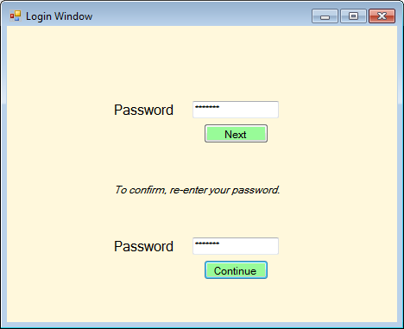

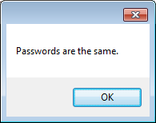

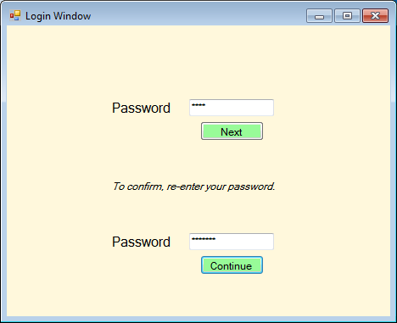

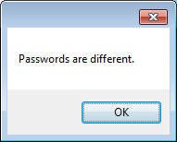

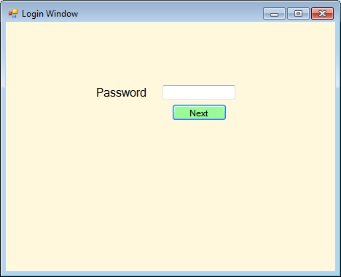

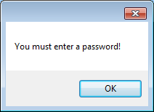

// ---------------------------------------------------------------

// Programming Assignment: LAB6A

// Developer: Anthony Meunier

// Date Written: 8/16/2014

// Purpose: Password Program

// ---------------------------------------------------------------

using System;

using System.Collections.Generic;

using System.ComponentModel;

using System.Data;

using System.Drawing;

using System.Linq;

using System.Text;

using System.Threading.Tasks;

using System.Windows.Forms;

namespace CIS170B_Lab6A_Meunier_A

{

public partial class Form1 : Form

{

public Form1()

{

InitializeComponent();

}

private void textBox2_TextChanged(object sender, EventArgs e)

{

}

//next button function

private void btnNext_Click(object sender, EventArgs e)

{

//declare variables

string password1, password2;

password1 = (txtPassword1.Text);

password2 = (txtPassword2.Text);

//verify first password textbox is not blank

if (!String.IsNullOrEmpty(txtPassword1.Text))

{

//make visible second password textbox etc

lblPassword2.Visible = true;

txtPassword2.Visible = true;

btnContinue.Visible = true;

lblConfirm.Visible = true;

}

//display error if textbox is empty

else

{

MessageBox.Show("You must enter a password!");

}

}

//continue button function

private void btnContinue_Click(object sender, EventArgs e)

{

//declare variables

string password1, password2;

password1 = (txtPassword1.Text);

password2 = (txtPassword2.Text);

//verify first password textbox is not blank

if (!String.IsNullOrEmpty(txtPassword1.Text))

//check if first password textbox equals second password textbox

if (password1 == password2)

{

MessageBox.Show("Passwords are the same.");

}

//check if passwords do not equal each other

else

{

MessageBox.Show("Passwords are different.");

}

//display error if textbox is empty

else

{

MessageBox.Show("You must enter a password!");

}

}

private void label1_Click(object sender, EventArgs e)

{

}

private void txtPassword1_TextChanged(object sender, EventArgs e)

{

}

}

}

**Part B: Number Guessing Game**

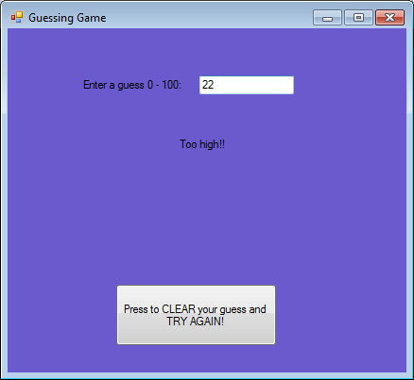

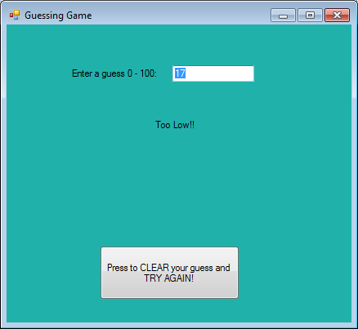

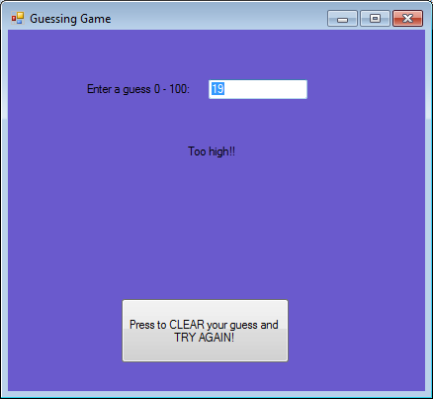

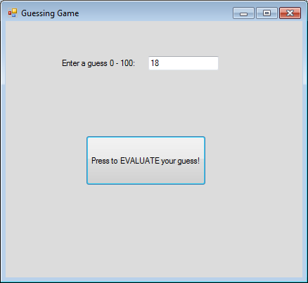

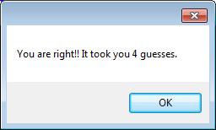

// ---------------------------------------------------------------

// Programming Assignment: LAB6B

// Developer: Anthony Meunier

// Date Written: 8/17/2014

// Purpose: Number Guessing Game

// ---------------------------------------------------------------

using System;

using System.Collections.Generic;

using System.ComponentModel;

using System.Data;

using System.Drawing;

using System.Linq;

using System.Text;

using System.Threading.Tasks;

using System.Windows.Forms;

namespace CIS170B_Lab6B_Meunier_A

{

public partial class Form1 : Form

{

//declare and initialize global variables

Random r = new Random();

int target;

int numGuesses = 0;

public Form1()

{

//randomly pick a target number between 0 and 100

InitializeComponent();

target = r.Next(0, 100);

}

private void Form1_Load(object sender, EventArgs e)

{

}

//evaluate button click function

private void btnEval_Click(object sender, EventArgs e)

{

int num1;

//check to make sure textbox is not empty

if (!String.IsNullOrEmpty(txtNumberEntered.Text))

{

//counter for number of guesses

numGuesses++;

//pull guess from the textbox

num1 = Convert.ToInt32(txtNumberEntered.Text);

//if guess is less than random computer target

if (num1 < target)

{

//make evaluate button invisible

btnEval.Visible = false;

//change the label message

lblMessage.Text = "Too Low!!";

//make the label message visible

lblMessage.Visible = true;

//change background color

this.BackColor = Color.LightSeaGreen;

//make try again button visible

btnTryAgain.Visible = true;

}

//if guess is greater than random computer target

else if (num1 > target)

{

//make the evaluate button invisible

btnEval.Visible = false;

//change the label message

lblMessage.Text = "Too high!!";

//make the label message visible

lblMessage.Visible = true;

//change the background color

this.BackColor = Color.SlateBlue;

//make the try again button visible

btnTryAgain.Visible = true;

}

//display message indicating user guessed correctly and display the number of guesses it took

else

MessageBox.Show("You are right!! It took you " + numGuesses + " guesses.");

}

}

//try again button click function

private void btnTryAgain_Click(object sender, EventArgs e)

{

//change the background color to original since we are trying guess again

this.BackColor = Color.Gainsboro;

//make the try again button invisible

btnTryAgain.Visible = false;

//clear the guess textbox

txtNumberEntered.Clear();

//make the label message invisible

lblMessage.Visible = false;

//make the evaluate button visible

btnEval.Visible = true;

}

}

}

--Anthony Meunier

--CIS 336

--Lab 6

set pagesize 50

set linesize 150

set echo on

--1

select book_customer.customerid, book_customer.firstname, book_customer.lastname,

NVL(to_char(book_customer.referred),'Not Referred') AS "Referred By"

FROM book_customer

WHERE referred IS NULL;

--2

select substr(isbn, 1,1)||'-'||

substr(isbn, 2,3)||'-'||

substr(isbn, 5,5)||'-'||

substr(isbn, 10,1)

AS "ISBN", title

FROM books

WHERE category = 'COMPUTER';

--3

SELECT category, to_char(sum(retail), '$999999.99') AS "Total Retail",

to_char(avg(retail), '$999999.99') AS "Average Retail"

FROM books

group by category having sum(retail) > 40.00;

--4

SELECT distinct title AS "Book Title", count(*) as "Number of Authors"

FROM books, book_author

WHERE books.bookid = book_author.bookid

GROUP BY title HAVING count(*) > 1;

--5

SELECT bookid, fname, lname

FROM book_author, author

WHERE author.authorid = book_author.authorid

AND bookid =

(SELECT bookid

FROM order_items

GROUP BY bookid HAVING sum(quantity) = (SELECT max(sum(quantity)) FROM order_items GROUP BY bookid));

--6

SELECT

book_customer.customerid,

book_customer.firstname ||' '|| book_customer.lastname AS "Customer Name",

book_customer.city

FROM order_items

JOIN book_order ON order_items.orderid = book_order.orderid

JOIN book_customer ON book_customer.customerid = book_order.customerid

JOIN books ON books.bookid = order_items.bookid

WHERE books.retail = (SELECT max(retail) FROM books);

--7

SELECT

distinct itemnum,

COUNT(*) AS "Total",

to_char(avg(quantity), '999.99') AS "Average",

min(quantity) AS "Minimum",

max(quantity) AS "Maximum"

FROM order_items

GROUP BY itemnum

ORDER BY itemnum ASC;

--8

SELECT

title,

pubdate,

DECODE(pubid, 1, 'PRINTING IS US',

2, 'PUBLISH OUR WAY',

3, 'AMERICAN PUBLISHING',

4, 'READING MATERIALS INC.',

5, 'REED-N-RITE',

6, 'LITTLE HOUSE',

NULL) AS "Publisher Name"

FROM books

ORDER BY "Publisher Name" DESC;

--9

SELECT

'The contact person for',

initcap(publishername) ||' is '|| initcap(contactname)||'.'

FROM publisher;

--10

SELECT

lastname,

city,

state,

quantity AS "Number Purchased"

FROM book_customer

JOIN book_order ON book_customer.customerid = book_order.customerid

JOIN order_items ON order_items.orderid = book_order.orderid

WHERE quantity > 2;

--11

select books.isbn, books.pubid, books.retail, publisher.publishername

from books

join publisher on books.pubid = publisher.pubid

where publishername = 'PRINTING IS US';

update books

set retail = (retail*1.05)

where pubid = (select pubid

from publisher

where publishername = 'PRINTING IS US');

select books.isbn, books.pubid, books.retail, publisher.publishername

from books

join publisher on books.pubid = publisher.pubid

where publishername = 'PRINTING IS US';

--12

SELECT

firstname,

lastname

FROM book_customer

WHERE referred = (SELECT referred FROM book_customer

WHERE firstname = 'JORGE'

AND lastname = 'PEREZ')

AND firstname <> 'JORGE'

AND lastname <> 'PEREZ';

--13

SELECT

distinct category,

COUNT(*) AS "Category Total",

to_char(sum(cost), '$999999.99') AS "Cost"

FROM books

GROUP BY category;

Anthony Meunier

DeVry University

DBM 405A

Week 7 Course Project

Write the Report

**Interface**

For the interface of the application, I created a GUI via Visual Basic with Windows Forms. Each button functions to take the user to the entitled screen when the button is clicked. In addition, each individual form pertaining to its corresponding table loads the data on its own when the form is loaded. There is also obviously an established connection from Visual Studio to the MySQL server which functions to pull of the data in (ability to add, modify, and delete will be in future project). ‘Log Out’ button takes the user back to the ‘Connect’ screen, and ‘View All’ returns user to the main menu where they can view all data as well as navigate to other table pages.

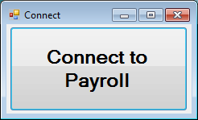

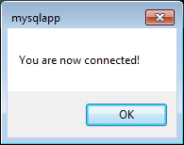

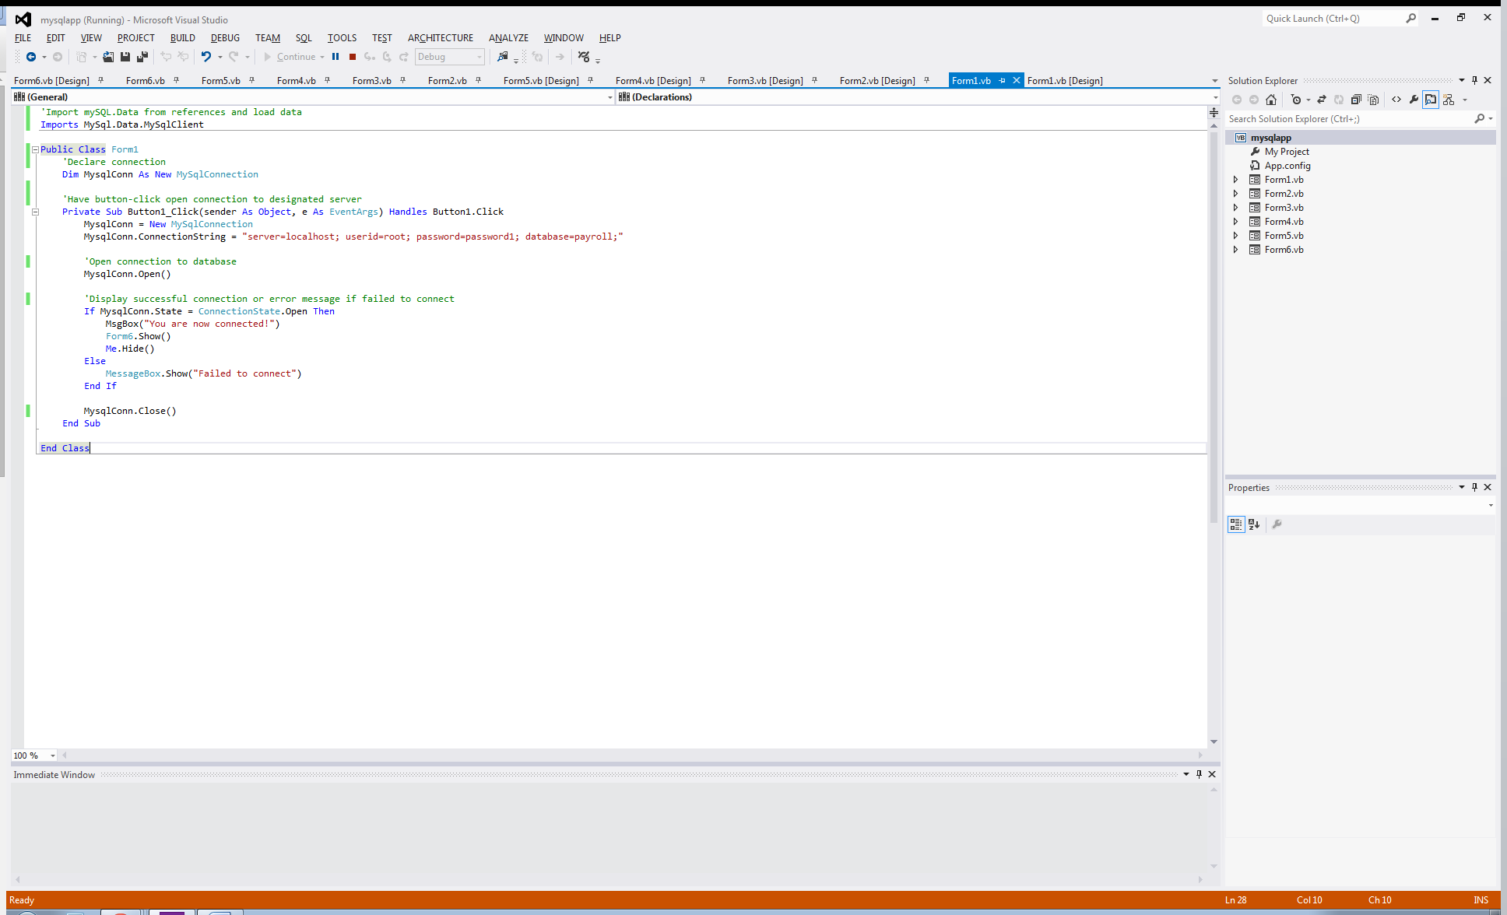

Please note the Imports MySql.Data.MySqlClient statement at the top of the code, as well as the connection string MysqlConn.ConnectionString = "server=localhost; userid=root; password=password1; database=payroll;" that references my specific MySQL server and database. Upon successful execution of this statement we have the ensuing MysqlConn.Open() that connects out application to the database for use/reference in Visual Studio.

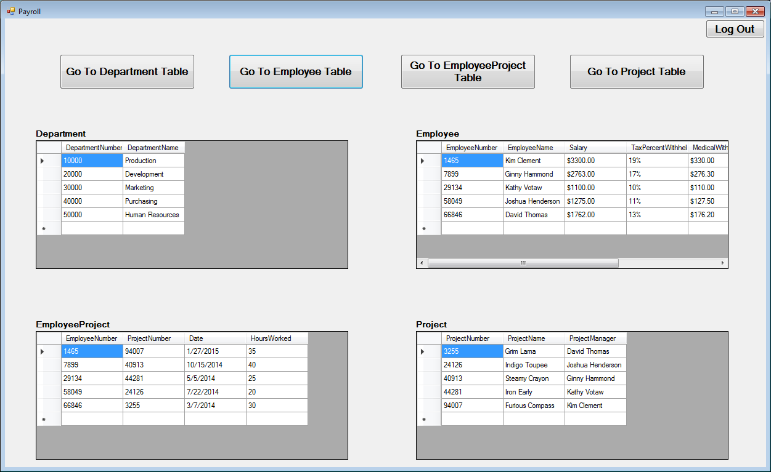

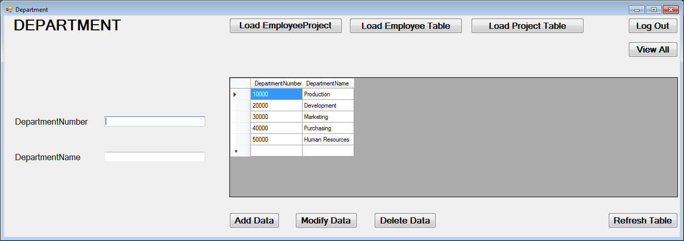

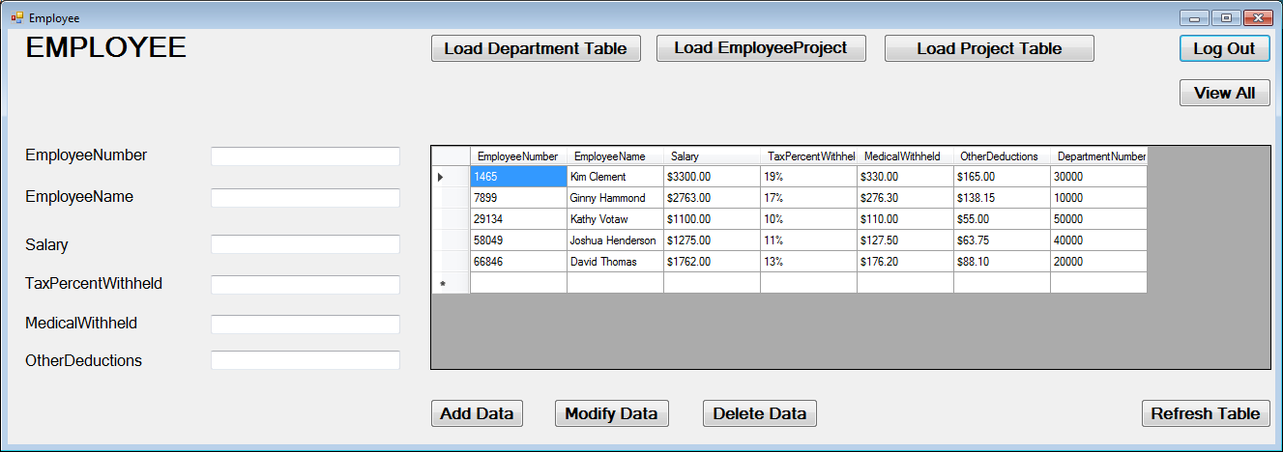

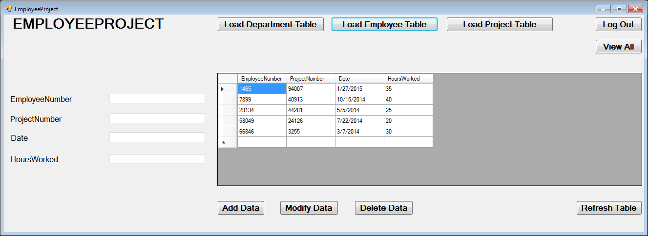

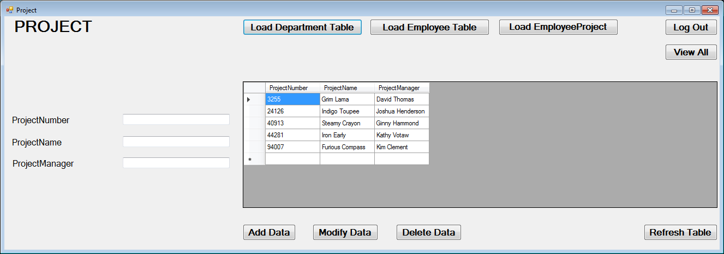

**Add/Delete/Update**

Writing the add/change/delete routines was fairly straightforward. Because I am using Windows Forms pages to serve as the interface for each respective table in the database, I simply had to write the routines one time (add, update/modify, delete) and then transpose them into the other Forms pages and then change the appropriate text to have them match the appropriate table and columns within the database. I have included in these routines a try/catch block that will either show an error if the data cannot be manipulated in the desired way or a window pop-up that displays a message to notify the user that changes have been made. In the example screenshots I will attach, you can see this process for each of the three routines. First I show the table as-is, type in the new information, press the appropriate button, display the successful message, show the table after the refresh button has been pressed, and also note the changes in the database application (Workbench) itself after we refresh in there. For the sake of space, I showed each of the routines functioning in one of the project tables, but since the code is appropriately updated in all Forms pages we can know that the routines are effective there as well.

Here I will paste each of the routines from Visual Basic for my “Project” table of the database. The attached project files will show that the code is exactly the same for all other tables, just updated accordingly to match those table’s names so the correct information is updated:

'Add data on button click

Private Sub Button3_Click(sender As Object, e As EventArgs) Handles Button3.Click

MysqlConn = New MySqlConnection

MysqlConn.ConnectionString = "server=localhost; userid=root; password=password1; database=payroll;"

Dim READER As MySqlDataReader

Try

MysqlConn.Open()

Dim Query As String

Query = "insert into payroll.project (ProjectNumber, ProjectName, ProjectManager) values ('" & TextBox_ProjectNumber.Text & "', '" & TextBox_ProjectName.Text & "', '" & TextBox_ProjectManager.Text & "')"

COMMAND = New MySqlCommand(Query, MysqlConn)

READER = COMMAND.ExecuteReader

MessageBox.Show("Data Added")

MysqlConn.Close()

Catch ex As Exception

MessageBox.Show(ex.Message)

Finally

MysqlConn.Dispose()

End Try

End Sub

'Update data on button click

Private Sub Button4_Click(sender As Object, e As EventArgs) Handles Button4.Click

MysqlConn = New MySqlConnection

MysqlConn.ConnectionString = "server=localhost; userid=root; password=password1; database=payroll;"

Dim READER As MySqlDataReader

Try

MysqlConn.Open()

Dim Query As String

Query = "update payroll.project set ProjectNumber='" & TextBox_ProjectNumber.Text & "', ProjectName='" & TextBox_ProjectName.Text & "', ProjectManager='" & TextBox_ProjectManager.Text & "' where ProjectNumber='" & TextBox_ProjectNumber.Text & "'"

COMMAND = New MySqlCommand(Query, MysqlConn)

READER = COMMAND.ExecuteReader

MessageBox.Show("Data Modified")

MysqlConn.Close()

Catch ex As Exception

MessageBox.Show(ex.Message)

Finally

MysqlConn.Dispose()

End Try

End Sub

'Delete data on button click

Private Sub Button5_Click(sender As Object, e As EventArgs) Handles Button5.Click

MysqlConn = New MySqlConnection

MsqlConn.ConnectionString = "server=localhost; userid=root; password=password1; database=payroll;"

Dim READER As MySqlDataReader

Try

MysqlConn.Open()

Dim Query As String

Query = "Delete from payroll.project where ProjectNumber='" & TextBox_ProjectNumber.Text & "'"

COMMAND = New MySqlCommand(Query, MysqlConn)

READER = COMMAND.ExecuteReader

MessageBox.Show("Data Deleted")

MysqlConn.Close()

Catch ex As Exception

MessageBox.Show(ex.Message)

Finally

MysqlConn.Dispose()

End Try

End Sub

**Screenshots of the Results**

Please see the below screenshots to see the effects of the add/delete/update routines on the “Project” table, both within the application and also the ensuing changes they have in the database environment as well. Again, code is the same with replaced table names for each table within the application; for the sake of space I am illustrating one example.

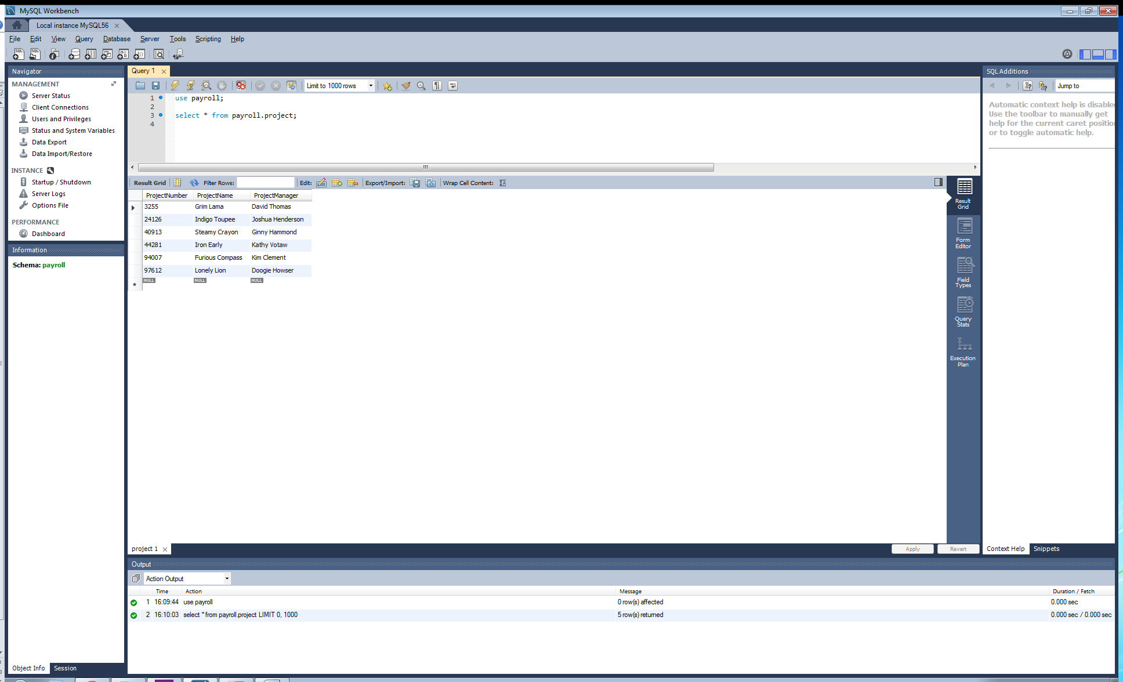

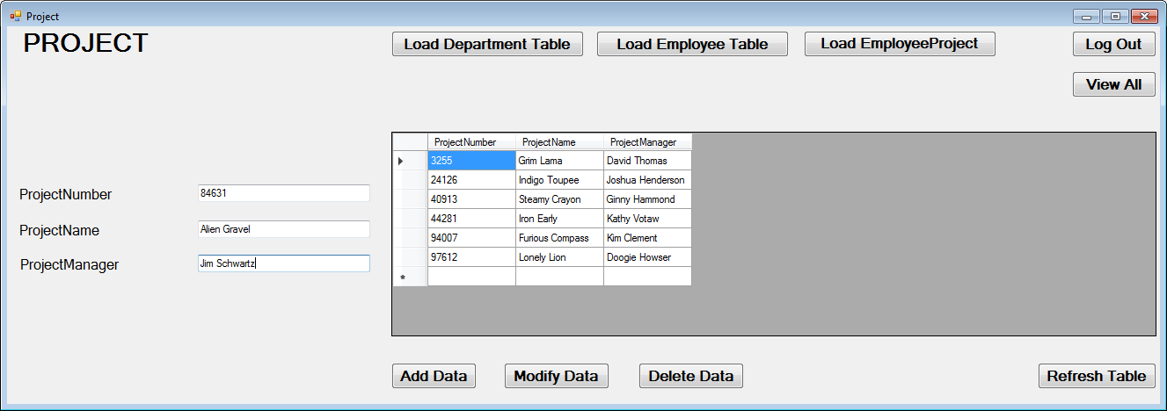

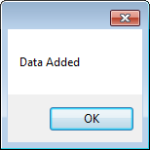

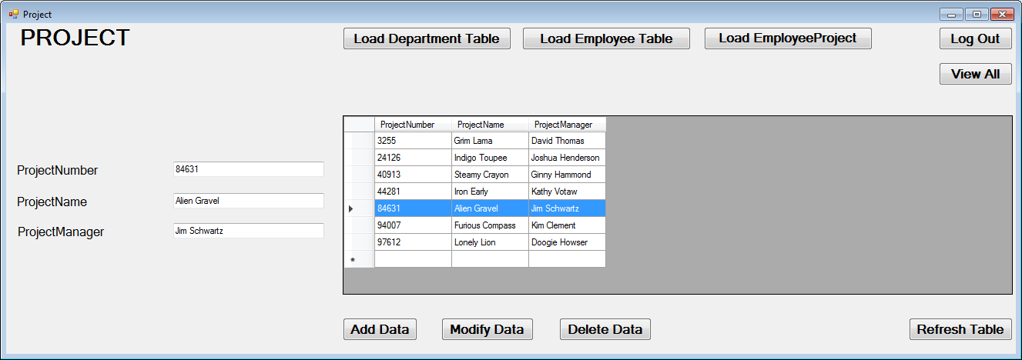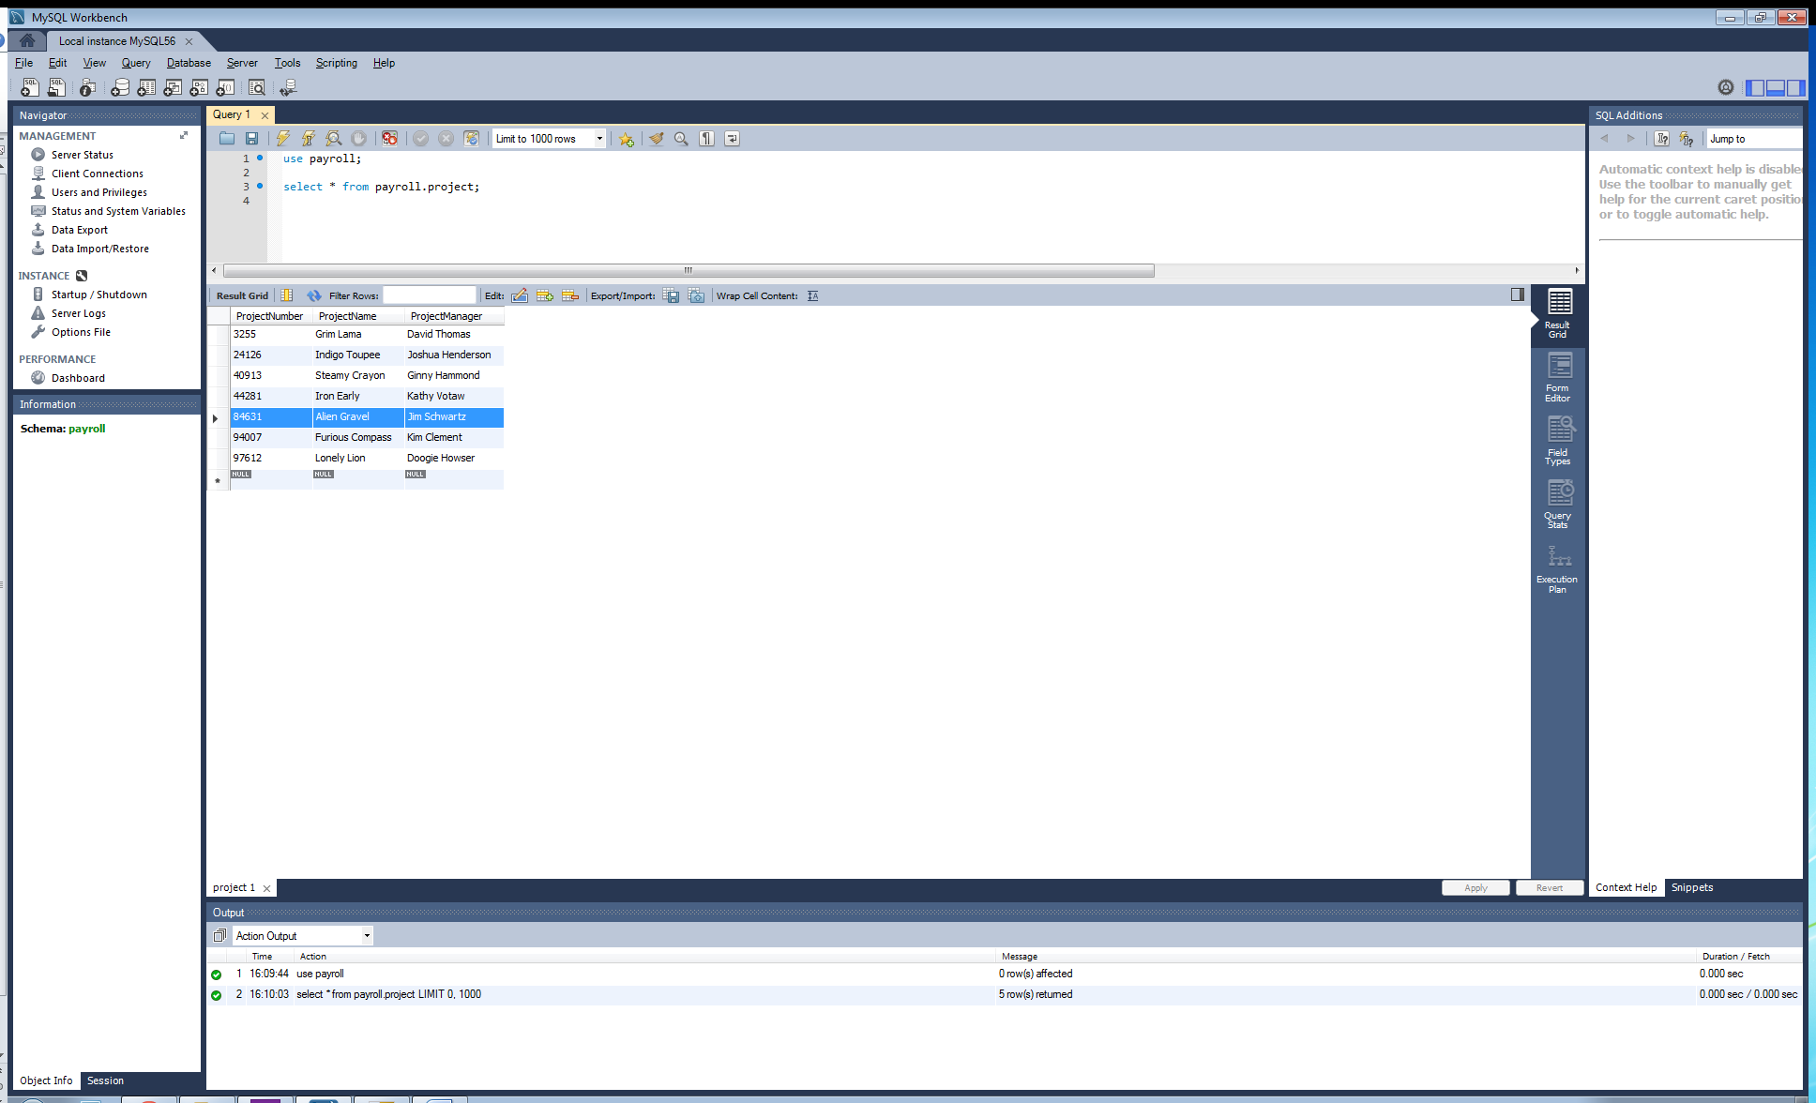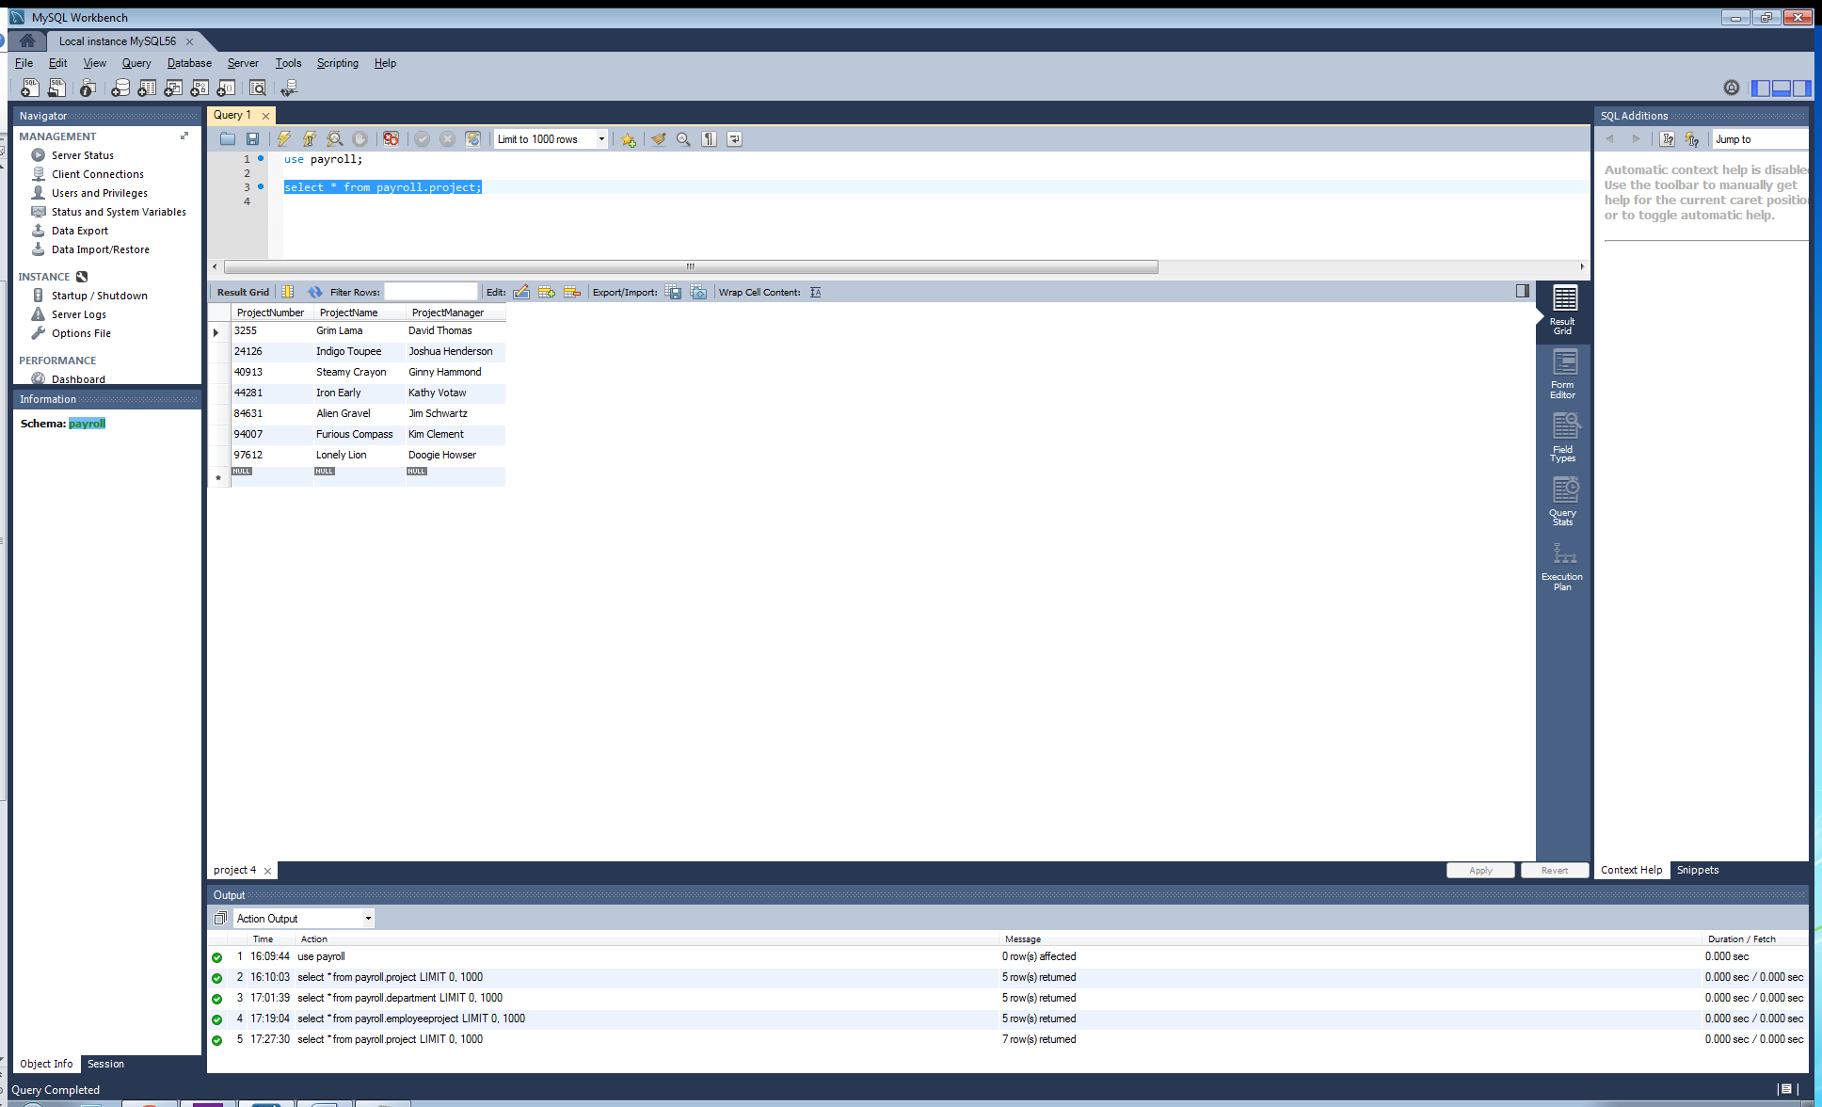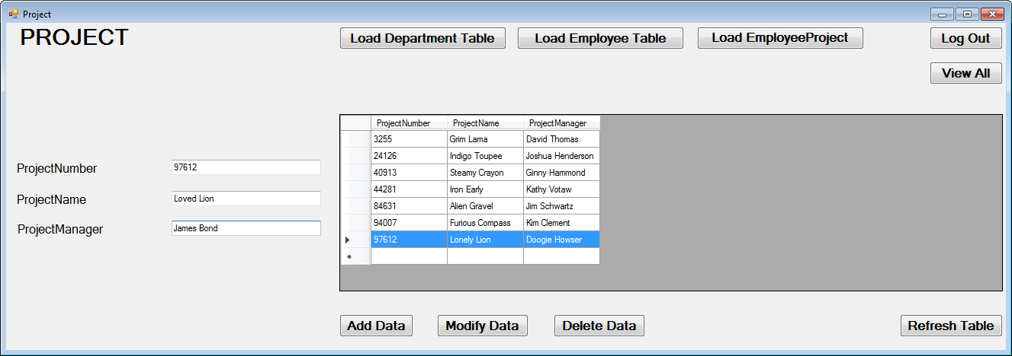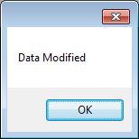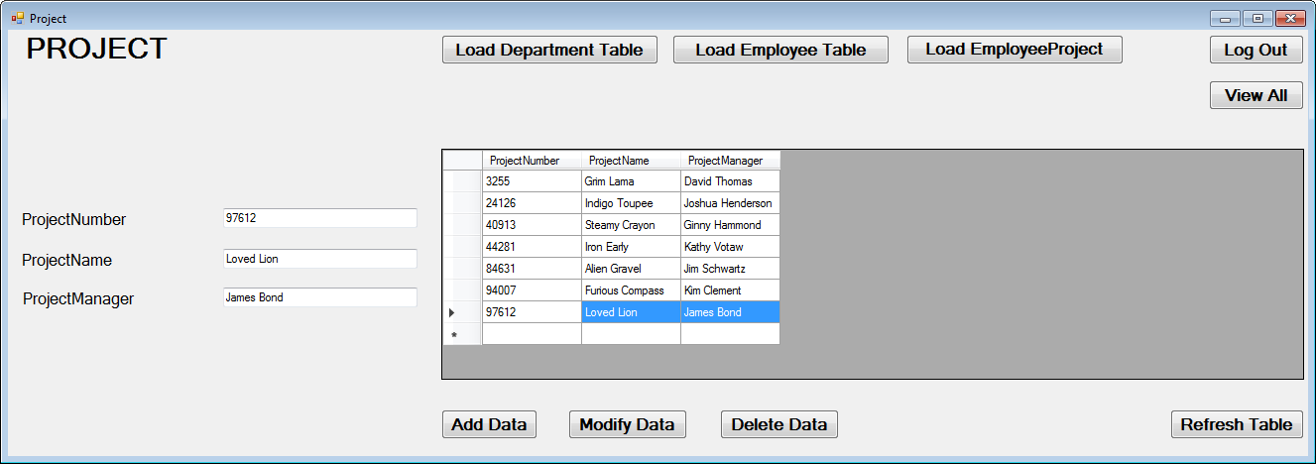

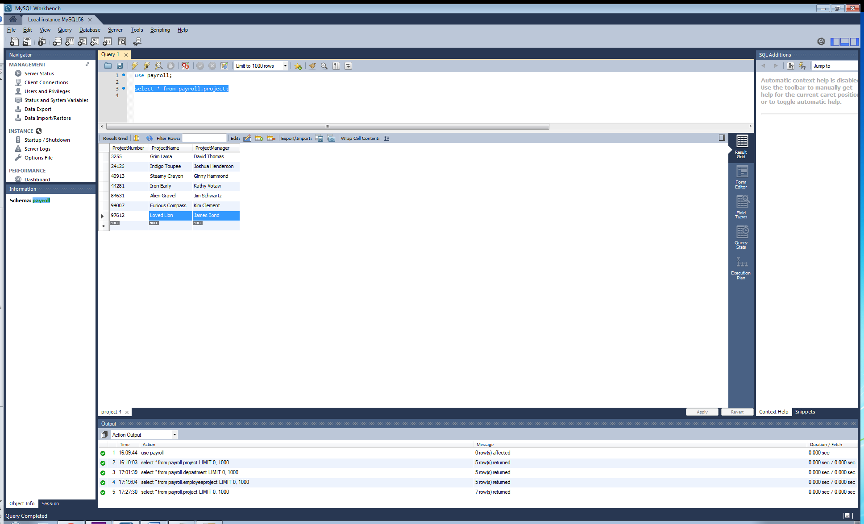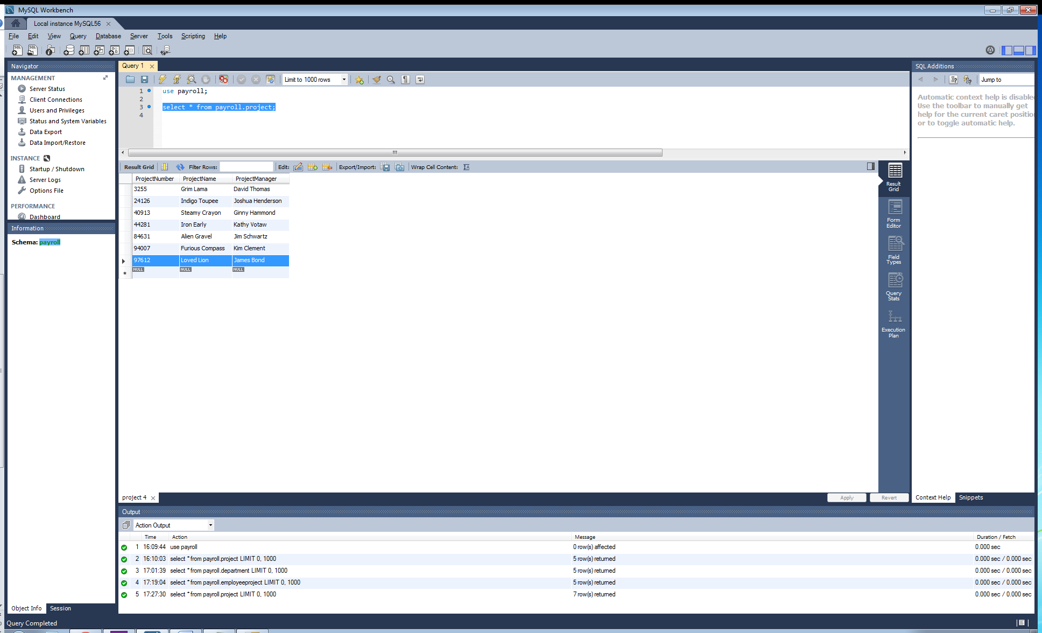

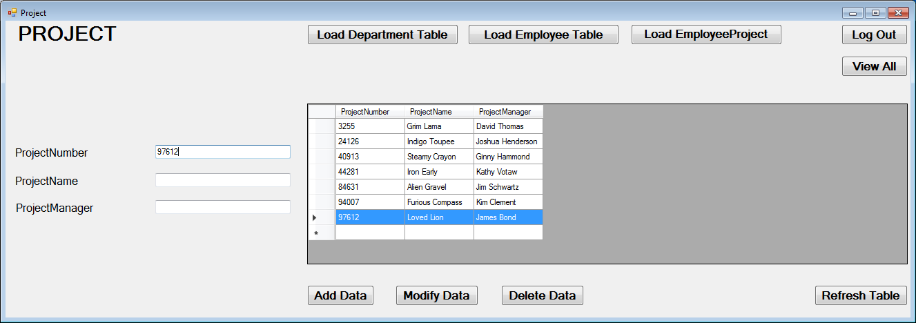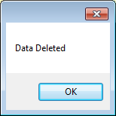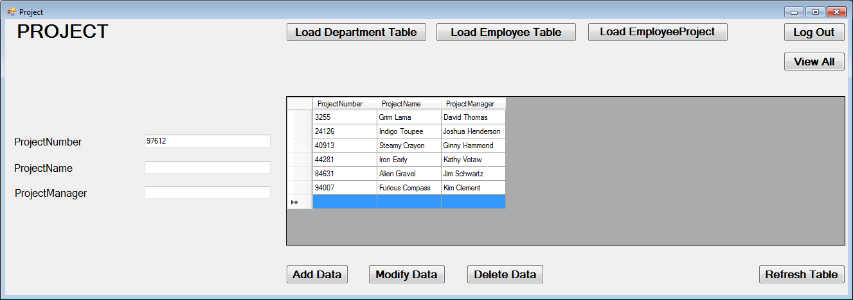

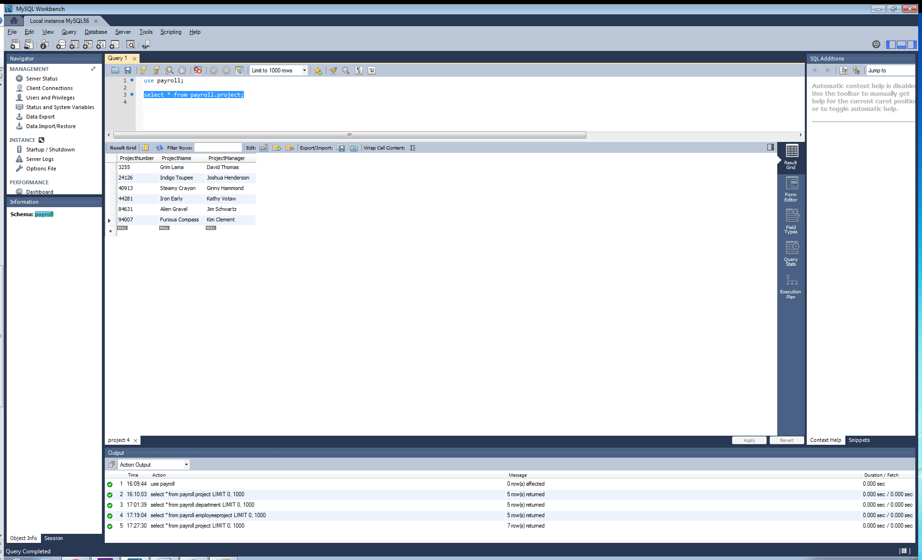

**Display/Print the Results**

I chose to use DataGridViews to serve as the container for my data to fill into to create a report to print/display the data from each table in the database. For these DataGridViews, I had one to coincide with each of the tables in my database, therefore you will find the DataGridView and the correct data for each table on each respective Forms page (i.e., “Department” Forms page loads department table data to DataGridView). In addition, I added two separate code blocks that load/display this data. First we have a structure that responds to a button press to load/refresh the data in the table/gridview. Second is a structure that automatically populates the DataGridViews upon loading each Forms page. Therefore we always have the data displayed to us on each respective Forms page, and then also have a button to refresh the data display if we have made changes using the add/change/delete routines. In addition, the “main menu” Forms page displays all data for all tables, all on the same page upon loading said page. Please see the code segment below for an example of one of my page’s DataGridView; first displaying the data on button press, and then just automatically loading/populating upon page load as well.

Code for one page is provided as the routines are the same for every other page except for switching the query to name the appropriate table.

'Fill DataGridView with MySQL table values when using "Refresh" button-click

Private Sub Load_Table_Btn_Click(sender As Object, e As EventArgs) Handles Load_Table_Btn.Click

MysqlConn = New MySqlConnection

MysqlConn.ConnectionString = "server=localhost; userid=root; password=password1; database=payroll;"

'Connect DataGridView with database table

'Get data with adapter

Dim SDA As New MySqlDataAdapter

'Bind data from adapter to DataGridView

Dim dbDataSet As New DataTable

Dim bSource As New BindingSource

Try

'Open connection to database

MysqlConn.Open()

'Declare query

Dim Query As String

'Query that will pull from database and return to DataGridView

Query = "select * from payroll.department"

COMMAND = New MySqlCommand(Query, MysqlConn)

SDA.SelectCommand = COMMAND

'Take values from query and fill to DataSet

SDA.Fill(dbDataSet)

'Bind DataSet to DataGridView

bSource.DataSource = dbDataSet

DataGridView1.DataSource = bSource

SDA.Update(dbDataSet)

MysqlConn.Close()

Catch ex As Exception

MessageBox.Show(ex.Message)

Finally

MysqlConn.Dispose()

End Try

End Sub

'Automatically load DataGridView upon page creation/load (same as above, just automatic and does not require refresh button press)

Private Sub load_table()

MysqlConn = New MySqlConnection

MysqlConn.ConnectionString = "server=localhost; userid=root; password=password1; database=payroll;"

Dim SDA As New MySqlDataAdapter

Dim dbDataSet As New DataTable

Dim bSource As New BindingSource

Try

MysqlConn.Open()

Dim Query As String

Query = "select * from payroll.department"

COMMAND = New MySqlCommand(Query, MysqlConn)

SDA.SelectCommand = COMMAND

SDA.Fill(dbDataSet)

bSource.DataSource = dbDataSet

DataGridView1.DataSource = bSource

SDA.Update(dbDataSet)

MysqlConn.Close()

Catch ex As Exception

MessageBox.Show(ex.Message)

Finally

MysqlConn.Dispose()

End Try

End Sub

Screenshots for each page successfully displaying the data will be provided below:

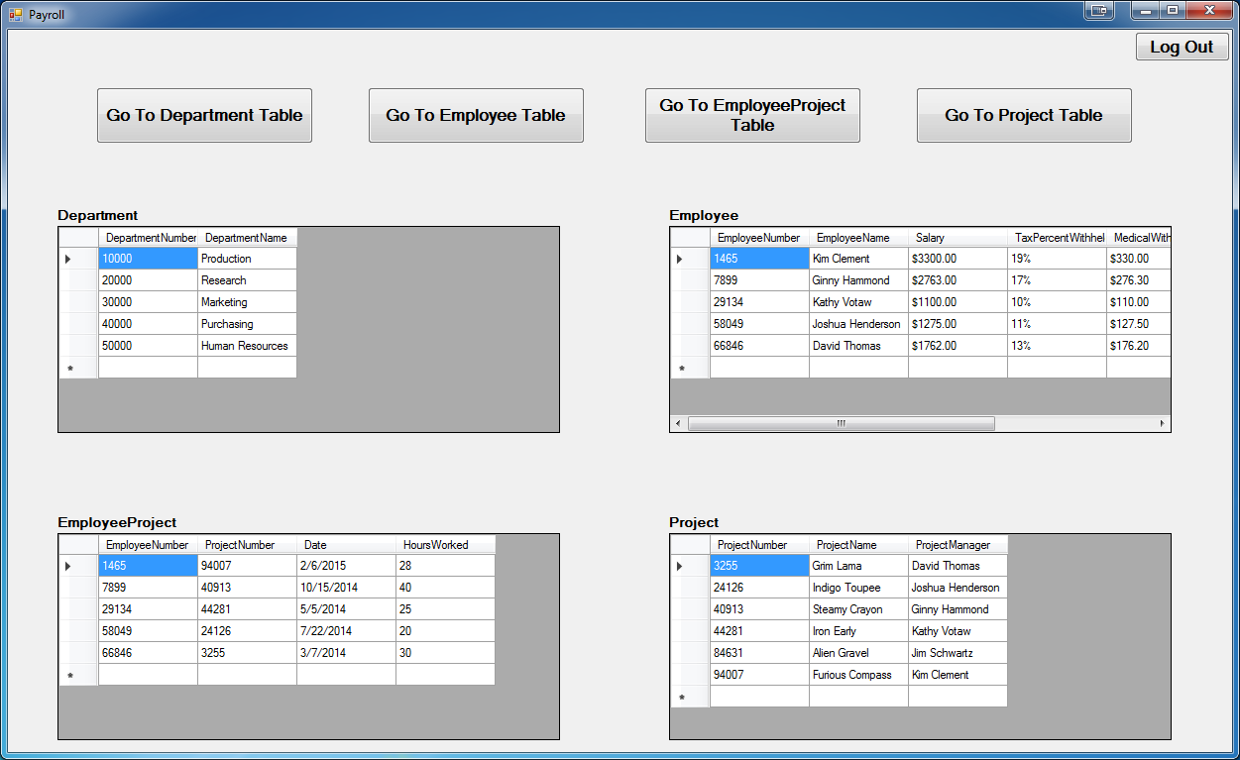

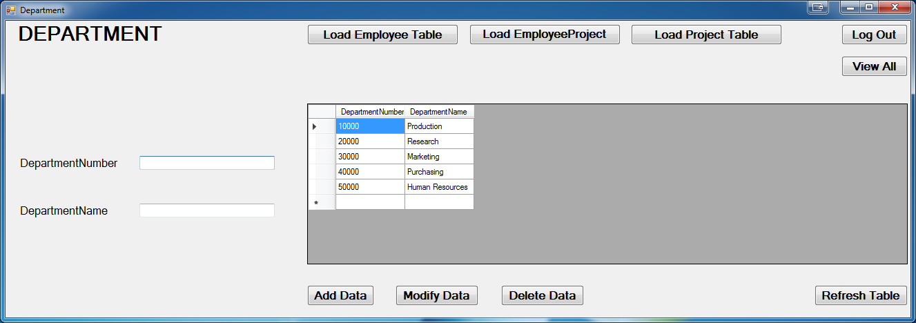

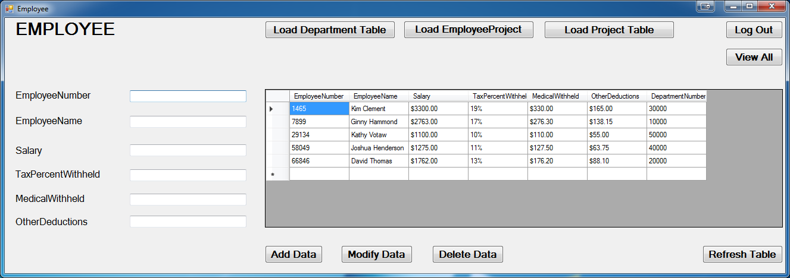

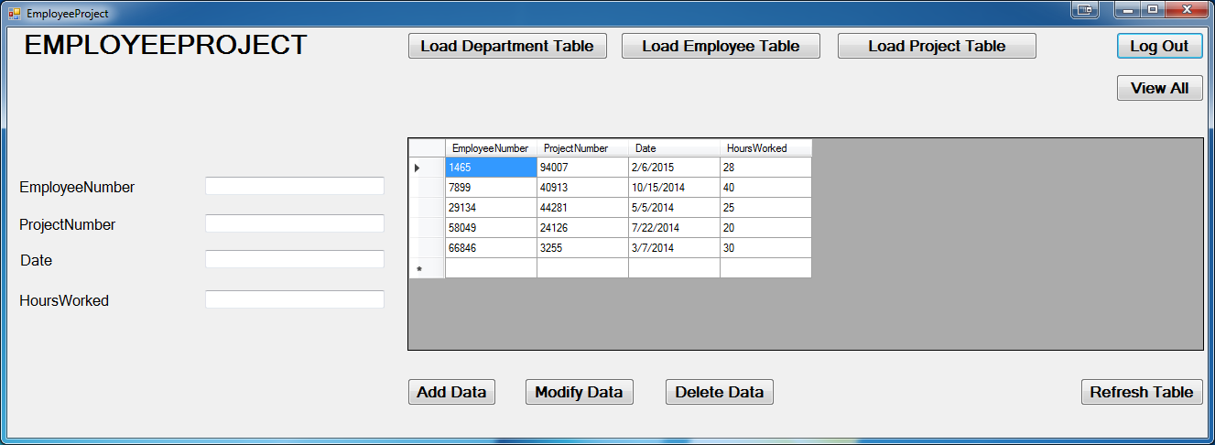

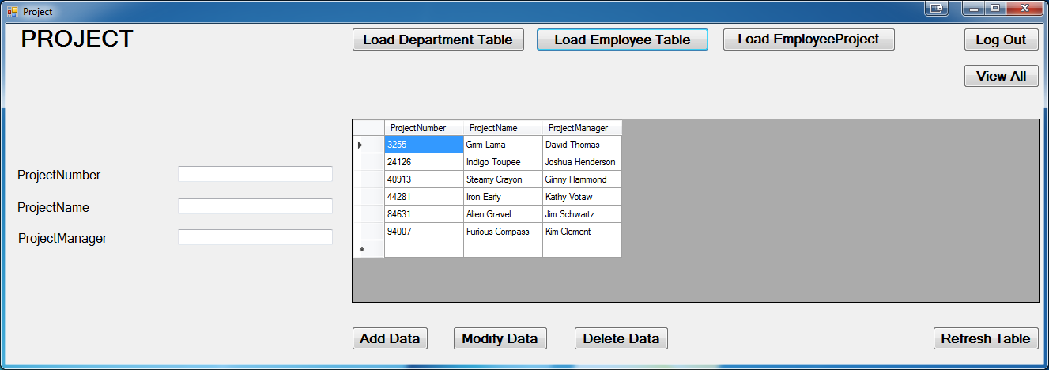

Anthony Meunier

DeVry University

CIS 339

Week 4 Lab

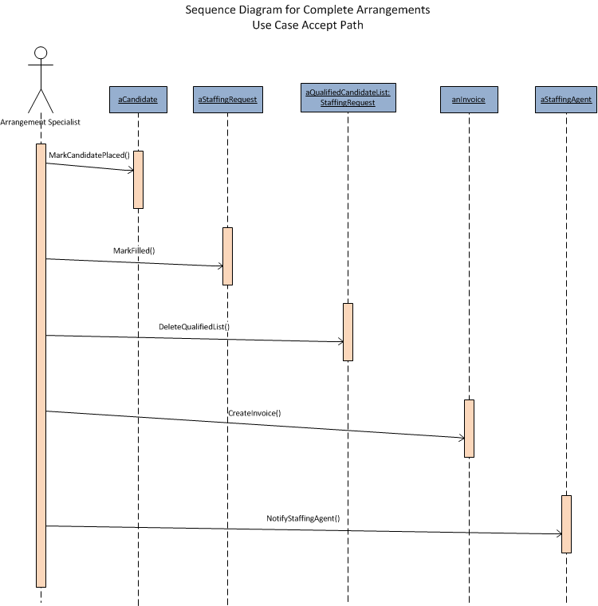

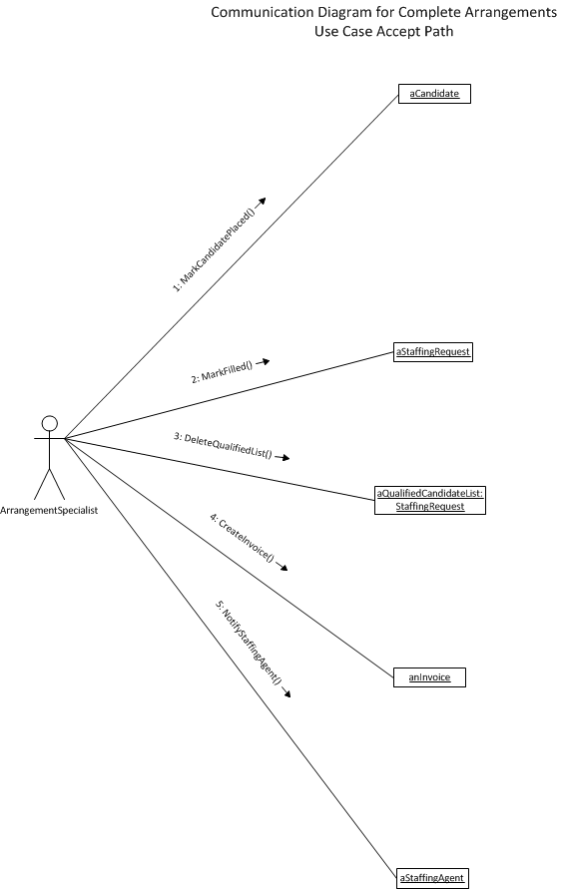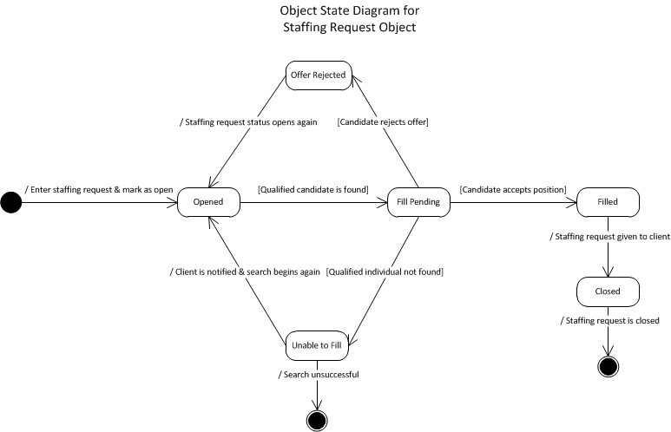

Anthony Meunier

SAI 460

Course Project

**III. Current IT Situation**

SAI Toys – SWOT Analysis

|  |  |
| --- | --- |
| Strengths | * Leading manufacturer of products for Gifted Electrical Engineering Kids (GEEKs). * Products are manufactured in-house. * Supplier of major retail stores and e-commerce-only sites with toys. * Public website provides a substantial amount information:   + Products   + Locations   + Warranty information * Manufacturing Support System (MSS) maintains the supply chain information to manufacture products:   + Raw materials   + Vendors   + Prices * Human Resources System (HRS) maintains and tracks personnel and benefits information. * Sales and Marketing System (SMS) tracks sales and marketing efforts of company’s entire sales force. |
| Weaknesses | * Company has multiple buildings on different sides of city which may cause unnecessary delays. * No direct interaction with consumers. * Anecdotal warranty information and stories from staff members; no proper system in place. * SMS manually prints and send orders daily to the MSS to be filled. |
| Opportunities | * Direct interaction with consumers through warranty service. This is an opportunity because the company could establish and provide a higher level of customer service. * Tracking warranty service details and defect rates is an opportunity for the company to highlight a quality product or focus on improving quality. * Automate SMS order information so there is less labor/time involved in fulfilling orders. * MSS maintains the supply chain information. This is an opportunity because the data can be used to justify how a “direct to consumers” service can maximize profits by cutting out the “middle man.” |
| Threats | * Not selling directly to consumers may allow competitors to establish secure/loyal customer base. * Website does not track warranty support details or defect rates. This is a threat because people want to know if the product is reliable. |

SAI Toys – AS-IS Process



SAI Toys – Competitive Strategy

